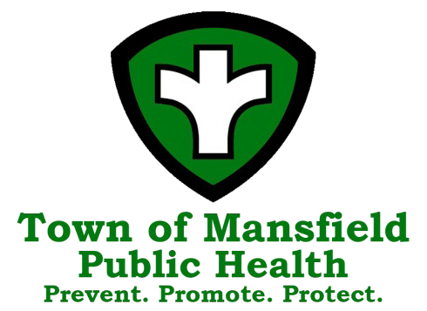
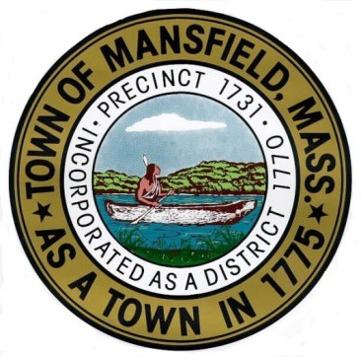
Town of Mansfield
Board of Health Agenda

June 26, 2025 – 7:00 PM

The mission of the Mansfield Board of Health is to protect, preserve and improve the public health, environment and wellbeing of our citizens through the enforcement of federal, state and local statutes and regulations, education and promotion of sanitary living and working conditions, and protection of the environment from disease and pollution.

7:00 PM Call to Order

7:01 PM Correspondence

7:05 PM Consent Agenda (Please see report at end of agenda)

7:10 PM Meeting Minutes
- April 10, 2025

7:15 PM Presentation on MAHB conference- Emily Beura and Christine West

7:35 PM Tobacco Sales Regulations Discussion
    - Nicotine-Free Generation
    - Inclusion of nicotine pouch restrictions

8:00 PM Update: Envision hotel pool discussion and possible vote to no longer require records to be sent weekly.

8:10 PM MHOA as Tobacco Agent- BOH vote

8:15 PM Pet dogs in Outdoor Dining Areas- BOH policy discussion

8:25 PM BOH Goals and Objective discussion- Communicable Disease Control and Chronic Disease & Injury Prevention

8:45 PM March 2025 Public Health Nursing report & Infectious Disease Updates

8:50 PM Report on Household Hazardous Waste Collection Day

8:55 PM Diversity Equity and Inclusion

8:56 PM Important Dates:
- Free Health Screenings including blood pressure, blood sugar, cholesterol, Hands only CPR and associated prevention information
  - 2nd Tuesday at the COA, 255 Hope Street, 9am-12pm
  - 3rd Wednesday at Town Hall, 6 Park Row, 9am-12pm

8:57 PM Department Updates
- Permitting
- Bristol-Norfolk Public Health Partners Coalition Grants Update
- PFAS
- Website/ Social Media Update
- Housing Inspections
- FOG
- Grants
  - FDA Retail Standards Grant

8:58 PM Visitor Comments

8:59 PM Items not known 48 hours prior

9:00 PM Adjournment

