Many thanks in advance for retaining boilerplate language that has not changed in the past year and for preserving established margins, line-spacing, paragraph indents, fonts and font treatments, headings and subheads, bullet point styles, table styles, and numbered or alphabetized list styles, etc. All these elements provide layout cues for our designer.

This template also reflects our house style, which we follow when copyediting and occasionally fact-checking so many reports. Preserving the treatment of professional titles, organizations, programs, acronyms, number usage, dates, year ranges, for example, will lessen how extensively we must copyedit your forthcoming 2023 report and thus reduce the possibility of introduced errors.

Please contact Mary Kalamaras at mkalamaras@doverma.gov or 301-535-4566 with any report prep questions. Thank you for your assistance and partnership in publishing a great town report!

Report of the
Dover-Sherborn High School

John G. Smith, Principal

Dover-Sherborn High School (DSHS) is a community of learners whose goal is to inspire academic excellence and a commitment to personal and civic responsibility. We engage in the learning process with honesty, creativity, dedication, and respect, and seek to cultivate an atmosphere of freedom and trust in a safe and nurturing environment.

DSHS is accredited by the New England Association of Schools and Colleges and consistently ranks among the top public schools for academic excellence in both Massachusetts and the nation. Our students excel in the classroom, on the stage as musicians and actors, and as athletes on the various playing fields and venues in our area. We are grateful for the support of our community and our parents and guardians.

Curriculum Requirements
In the 2022–23 school year, DSHS served approximately 660 students in grades 9 through 12. Each year, over 90% of graduating students attend four-year colleges and universities. To graduate, all students must complete four years of English, four years of mathematics, and three years each of laboratory sciences, social studies, and world language. They must also earn 18 credits in the fine and performing arts and/or technology, engineering and computer science and 12.5 credits in wellness (physical and health education). In addition, they must complete 40 hours of community service and pass the required state MCAS (Massachusetts Comprehensive Assessment System) exams.

Although DSHS offers three levels of courses in each of the academic disciplines, students are not tracked. DSHS also does not compute “rank-in-class” for its students, a policy approved by the Dover-Sherborn Regional School Committee.

Most departments offer a variety of courses that are heterogeneously grouped. The schedule is based on an eight-day rotation. All primary courses (and most electives) meet six times out of the eight-day cycle, and each class meets for nearly an hour. Laboratory sciences may meet up to two additional periods each cycle.

Academic Testing
PSAT
The PSAT was offered in October 2022 to juniors and sophomores. One hundred ten juniors (63% of the class) and 108 sophomores (70% of the class) took the test. Based on their scores, 21 students received National Merit Scholarship Program Letters of Commendation and 2 students were recognized as National Merit Semi-Finalists.

SAT
- SAT I: Seventy-nine percent of the Class of 2023 took the SAT test. Of the students who took the SATs, 77% earned a combined score of over 1200 in Evidence-Based Reading & Writing and in Mathematics. The following table shows the average of the highest SAT test scores for the Class of 2023 and the previous senior class as calculated in Naviance. Compared with national and state averages, DSHS students significantly outperform their peers.

SAT Mean Scores
 | Class of 2022 |  |  | Class of 2023
 | DSHS | MA | US | DSHS | MA | US
Evidence-Based  Reading & Writing | 641 | 567 | 529 | 648 | 560 | 520
Mathematics | 651 | 561 | 521 | 643 | 551 | 508

AP
Fifteen AP (Advanced Placement) courses were offered during the 2022–23 academic year. These courses are typically offered during the junior and senior years and allow students to maximize their educational opportunities within the confines of the master schedule and graduation requirements. All students receiving AP credit are expected to take the AP examination at the end of the year. In spring 2023, 223 students took 540 examinations. The results for individual courses are as follows:

AP Course | # Students | Students Scoring 3 or Higher (%)
Biology | 44 | 100
Calculus AB | 16 | 100
Calculus BC | 24 | 100
Chemistry | 42 | 100
Computer Science A | 23 | 96
English Language and Composition (G-11) | 74 | 92
English Literature and Composition (G-12) | 51 | 100
French Language and Culture | 11 | 100
Latin (Not offered in 2021–22) | 05 | 100
Physics C: Mechanics | 17 | 94
Spanish Language | 12 | 100
Statistics | 48 | 79
Studio Art: 2D Art & Design | 11 | 82
U.S. Government and Politics (G-12) | 75 | 92
U.S. History (G-11) | 78 | 99

MCAS
For the 2023 MCAS exams, the Commonwealth is using the Next Generation MCAS test. The testing highlights for DSHS students are as follows:

- English Language Arts: Eighty-six percent of sophomores met or exceeded expectations (state average 58%).
- Mathematics: Eighty-eight percent of sophomores met or exceeded expectations (state average 50%).
- Science and Technology/Engineering: Eighty-six percent of sophomores met or exceeded expectations (state average 47%).

Graduate Post-Secondary Plans
 | Class of 2021 | Class of2022 | Class of2023
Four-Year College | 94% | 93% | 96%
Two-Year College | 1% | 2% | <1%
Post-graduate Program | 2% | 2% | <1%
Other (gap year, job) | 3% | 3% | 3%

Departmental Highlights
ENGLISH
The English Department offers courses at two levels (honors and college preparatory) for freshmen and sophomores, and at three levels (honors, college preparatory, and advanced placement) for juniors and seniors. During their freshman year, students focus on the themes of identity and self-discovery through their study of short stories, novels, drama, poetry, and nonfiction. Sophomores explore great themes in literature and hone their analytical and expository writing skills. Juniors not enrolled in AP English Language take a full year of American Literature at either the honors or college preparatory level. Seniors not enrolled in AP English Literature enroll in two of five same-level courses in focused areas, such as contemporary literature, poetry, film, and nonfiction studies. Advanced Placement courses include English Language and Composition offered to juniors, and English Literature and Composition offered to seniors.

Through effective reading, writing, and critical thinking, we hope our students will use their language and communication skills to understand more about themselves, their world, their responsibility toward others, and their place in both the local and global
communities.

MATHEMATICS
The Mathematics Department provides standard courses at honors and college preparatory levels, with Algebra 1 or Geometry in grade 9, Geometry or Algebra II in grade 10, and Algebra II or Precalculus in grade 11. Several electives are offered in grade 12, depending on previous levels of proficiency attained: AP Calculus BC, AP Calculus AB, Honors Calculus, AP Statistics, Probability and Statistics, and Precalculus and Applied Topics. We have also added a new semester-long elective course, Financial Literacy available to students in grades 11 or 12 who have passed Algebra II.

The Dover-Sherborn Math Team, a member of the Southeastern Massachusetts Mathematics League, continued its strong tradition of success, placing third out of 36 schools in Southeastern Massachusetts and third in the league playoffs, which is a single competition of the top 10 teams. Our team also competed in the Massachusetts State Championships, held remotely due to the lingering effects of COVID-19. Within this competition, Dover-Sherborn had one of its best performances to date, finishing second among the small and medium-sized schools throughout the state.

SCIENCE
The Science Department provides a rigorous curriculum sequence at the advanced placement, honors, and college preparatory levels, with three years of coursework required for graduation: Biology in grade 9, Chemistry in grade 10, and Physics in grade 11. Electives open to juniors and seniors are AP Biology, AP Chemistry, AP Physics, Advanced Topics in Biology, Anatomy and Physiology, Astronomy, Environmental Research, Forensic Science, and Marine Science.

The Science Olympiad team has been performing well in monthly West Suburban Science League competitions and is currently ranked 4th. Last year five AP Chemistry students were nominated by their teacher to compete in the sectional competition of the U.S. National Chemistry Olympiad, the Avery Ashdown Exam. One student placed in the top 25 students in Eastern Massachusetts. This high score qualified him to compete in the national chemistry exam against the top 900 students in the country. Last spring AP Physics students earned first place at the Eastern Massachusetts Physics Olympics. Physics students also demonstrated a quantum diamond exhibit at the Museum of Science.

SOCIAL STUDIES
Courses are offered in history and the social sciences at both the honors and college
preparatory levels for freshmen and sophomores and at three levels (college preparatory,
honors, and advanced placement) for juniors and seniors. World History I & II and U.S.
History are required of all students. Electives include AP American Government,
Government and Law, Economics, Introduction to Psychology, and Facing History.
In 2023, 92% of our A.P. U.S. Government students qualified with a passing score of 3 or better, while the national average was 49%. In A.P.U.S. History, 99% of our students qualified with a score of a 3 or better, while the national average was 48%.

The Social Studies Department’s enrichment programs and activities include the
EPIIC Tufts Inquiry Program; a Model U.N. Simulation in Boston; Mock Trial with our team finishing 3rd in the state competitions this year and the Close-Up Program, which is a weeklong government studies program in Washington, D.C.

The Department's 2023 Summer Reading Program for grades 9–12 continued to focus on themes and issues of systemic racism, various distinct cultures within American society, and the growing polarization in American politics.

Honors and Awards: Several students received honors or awards in 2022. One student
received the Daughters of the American Revolution Award for excellence in character,
service, leadership, and patriotism; two students each received a youth leadership award and
represented DSHS at the Hugh O’Brien Sophomore Youth Leadership Conference; one
student received the Fredrick Douglass and Susan B. Anthony Community Service and
Social Justice Award; and another student received the Social Studies Award presented at
the Senior Academic Award Night.

WORLD LANGUAGE
The World Language Department offers four-year sequential programs in French, Spanish, Latin, and Chinese, in both honors and college preparatory tracks. Students progress from novice to intermediate stages of language proficiency in French, Spanish, Latin, and Chinese. AP French Language and Culture, AP Latin, and AP Spanish Language and Culture courses are offered.

Honors and Awards: A number of World Language students received honors for the 2022–23 school year. In fall 2022, 26 students were inducted into the Dover-Sherborn World Language Honor Society for their achievement and dedication to learning world languages and cultures. In May 2023, seven students received awards from the Massachusetts State Seal of Biliteracy: one in French and six in Spanish.

FINE AND PERFORMING ARTS
Performing Arts (Theatre and Music): Courses offered include Music Theory, Guitar I and II, and a newly added Acting Workshop course. Additionally, three ensemble courses are offered: Chorus, Concert Band, and the Jazz Band (by audition). These groups perform at many school and community events throughout the year. Course offerings and their adjacent performances seek to provide opportunities for the creation and enjoyment of music for all D-S students and community members.

Schedule changes made 4 years ago that improved access to ensembles for the student body continue to show a positive effect, with the Concert Band and Chorus showing high school enrollment consistently over 60 students in each ensemble for the past 4 years. These numbers are more than double enrollment numbers prior to 2020 when the change was made.

Visual Arts: Courses offered include Art 2D, Art 3D, Ceramics I and II, AP Studio Art, Darkroom Photography, Digital Photography, Yearbook Design I, II, and III, Graphic Design, and Screen Printing. These course offerings provide the opportunity for all D-S students to create and enjoy art.

Honors and Awards: D-S students and their teachers continue to distinguish themselves in activities and competitions outside the school:

- Scholastic Art Awards recognized three of our students for their artistic works. Collectively these three students received 4 Gold Key, 1 Silver Key, and 2 Honorable Mentions.
- Eastern District Senior Festivals, sponsored by the Massachusetts Music Educators’ Association (MMEA), awarded honors to six students, three of whom went on to perform at the MMEA All-State Festival at Symphony Hall in Boston, and one student also went on to perform regionally at the All Eastern Festival.

TECHNOLOGY, ENGINEERING, AND COMPUTER SCIENCE
During the past nine years, the primary goal of the Technology, Engineering, and Computer Science Department has been to more strongly align the grade 6–8 and grade 9–12 curriculums to better prepare students for college courses in computer science and engineering. To build a strong foundation for their subsequent high school courses, Dover-Sherborn Middle School (DSMS) students take engineering courses at all three grade levels, and students in grades 6 and 7 take computer science, with a heavy emphasis on programming. During their 8th grade engineering course students will complete a capstone style project that includes their previously learned coding skills with a hands-on aspect, this project includes coding a video game and building and wiring a controller. At the high school level, 14 new courses have been created over eight years. All course offerings, both new and previously existing, are now a continuation of the DSMS curriculum. The entire curriculum for each course offered in grades 6–12 is reviewed and updated each year. During the 2022–23 school year, we focused on cultural responsiveness and worked to add meaningful and thought-provoking units to each course. In 2022–23, we will continue thoroughly examining our curriculum units for their equality and diversity.

The Department offers the following computer courses for high school students: Social Media Literacy, Intro to CAD, Web Design Using HTML & CSS, Computer Programming with Java Script, Technology and Society, iOS App Design, Video Game Design, and a capstone AP Computer Science course for sophomores, juniors, or seniors. Our newest course offerings will include a business course and also the AP computer science A for the 24-25 school year. The Department also offers engineering and technology classes, including TV Media I, II, and III, and Industrial Technology I and II. A yearlong Engineering course is offered at both the college preparatory and honors levels and may be taken for science or elective credits that count toward graduation.

WELLNESS
The Freshman Wellness Curriculum requires one semester each of Contemporary Issues covering nutrition, sexuality, mental health, and alcohol, tobacco, and other drugs; and one semester each of Outdoor Education (one quarter) and Fitness Development (one quarter). Students in grades 10–12 can choose from the following electives: Cardiovascular Fitness, Outdoor Pursuits, General Survival, Student Leadership Internship, Stress Management, Sport Education (Net Sports, Winter Team Sports), Dance Education, CPR/AED Training, Yoga/Pilates, Coaching, Teaching, Recreation and Leadership, Fitness Program Planning, Drugs and Society, Muscular Fitness, Sports and Society, RAD (Rape, Aggression, Defense Systems), and Target Sports.

GUIDANCE
College Counseling: Eighty-eight percent of the Class of 2023 completed some form of early decision, priority, or early action applications to colleges and universities. To respond to the growing number of early college applications, counselors facilitate a five-class seminar series for grades 11 and 12. Juniors participate in spring classes that help prepare them in advance for college applications, including completing their resumes, beginning their essays, and starting work on their Common Application. Seniors begin their seminar series during the first week of school and can complete their Common Application online, add schools to Naviance, edit and complete their essays, and participate in mock interviews. Seminars covering stress management, high school transition, and career and personal exploration are also available to freshman and sophomores.

Counselors meet with seniors individually and in groups. They also host representatives from more than 100 colleges and universities and spend time strengthening their working relationships. Counselors meet several times with juniors individually to discuss the college application process and to guide their post-secondary educational planning. Counselors also meet with freshmen and sophomores to discuss their academic and future career plans, as well as introduce them to online programs that aid students in college and career exploration. An overview of the guidance curriculum can be found on the high school website.

Support Programs: The Guidance Department offers several support programs:
- Freshman welcoming activities support freshmen during their transition to high school.
- The Peer Helper Program this past year trained 40 upper-class students to assist incoming freshman with healthy decision-making, respect for others, study and exam-taking strategies, social issues, and expectations for their sophomore year.
- The Signs of Suicide (SOS) Program for sophomores and seniors teaches students how to identity the symptoms of depression and suicide in themselves or their friends and encourages them to seek help.
- Parent-departmental meetings are held throughout the year to discuss important issues and concerns specific to each grade level.

LIBRARY
The DSHS library is a place where students and faculty can read, research a topic, access information, or complete a homework assignment. It is equipped with large tables for student collaboration, private study booths, and 16 computers for word-processing or online searches. The collection includes approximately 20,000 print volumes, six newspapers, and 20 periodicals. In addition, patrons can search the library catalog for a growing collection of e-books. Digital services include online databases available from Massachusetts Regional Library System and those purchased by subscription, as well as thousands of e-books and audio-based materials via OverDrive. The library houses a portable cart with 25 iPads and 15 Chromebooks for classroom use. An average day brings approximately 300 students and teachers to the library.

ATHLETICS
The past year was extremely successful for DS athletics in both the classroom and on the playing fields. DS was awarded second place (to Norwell High School) by the Globe for the D4 Ames award, which is awarded to the most winning athletic program in the division in the state. DS Athletics put together a 205-97-13 overall record (67.14 winning percentage) across all three seasons. The student athletes and coaches worked extremely hard in both areas, which paid off as the teams brought home a lot of hardware for the trophy case. During the week of graduation the athletic department recognized 16 student athletes to play college athletics in the Fall of 2023, which was made up of eight females and eight males each playing a sport at the next level.

Winter Sports 2022-2023: DSHS had 265 student athletes compete across 13 sport offerings in the 2022-2023 Winter Season. The boys and girls basketball teams both won the TVL Small Championship Title for the first time in school history. This was the first league title ever for the girl’s basketball program. The boy’s basketball program made the MIAA D3 tournament and lost in the first round, and the girl’s basketball program advanced to the MIAA D3 Elite 8 Game at Rockland. Boys Alpine Ski won the MBE League, and the Girls Alpine Ski team came in second in the MBE League. The Boys Alpine Ski Team placed 3rd at the MIAA State Race, and the girls alpine ski team placed 12th at the MIAA State Race. The boy’s ice hockey team qualified for the MIAA D4 Tournament, qualifying for the Sweet 16 Round at Sandwich after upsetting Boston Latin Academy in the MIAA D3 Round of 32. The girl’s ice hockey team qualified for the MIAA D1 State Tournament at Winthrop. The boys and girls Nordic teams, the boys and girls swim and dive teams, and the boys and girls indoor track and field teams all qualified for the MIAA state tournament. Winter teams with TVL MVP honors were boy’s basketball.

Spring Sports 2023: DSHS had 301 student athletes compete across nine sport offerings in the 2023 Spring Season. The girl’s lacrosse team won the TVL Small, along with their third state title in a row by beating Ipswich 10-9 at Babson! The boy’s lacrosse team won the TVL Small and advanced on to the MIAA D4 Final Four Game vs. Sandwich. The boy’s tennis team was MIAA D3 State Finalist and TVL Small Champions. The girl’s tennis team was MIAA D3 Final Four Finalists and TVL Small Champions. The baseball team qualified for the MIAA D3 State Tournament and won their preliminary game to advance onto the Round of 32. Girl’s track and field broke records in the 1600 SMR and 3xTJ relay. Boy’s track and field broke records in the 1600 SMR and the 4x100. The sailing team competed in six races finishing 11-18 in those races. Spring teams with TVL MVP honors: girl’s lacrosse, boy’s lacrosse, boy’s tennis and boys track and field. Spring teams will TVL Coach of Year honors: girl’s tennis, boy’s lacrosse and girls lacrosse.

Fall Sports 2023: DSHS had 292 student athletes compete across seven sport offerings in the 2023 Fall Season. The golf team won the MIAA D2 State Championship, which was their second state championship in three seasons! Sophomore, Charlie Potter, became the MIAA D2 Individual State Champion shooting a 72 on the day. They were also TVL Small Champions going 11-0 in the TVL on the season and 14-2 overall, as well as the MIAA D2 Sectional Champions to qualify for the state championship. The girls cross country team were MIAA D2 State Finalists at all States, and MIAA D2 State Finalists at Divisionals, which was the best finish in school history! The girls cross country team were also TVL Small Champions! The boys cross country team were MIAA D2 State Finalists at Divisionals, and they finished 11th at MIAA All States. The boys and girls cross country 2023 teams had the best combined finish in school history! The girls’ soccer team were TVL Small Champions and MIAA D3 Final Four Finalists for the second season in a row! The field hockey team was TVL Small Champions and was also MIAA D3 Final Four Finalists for the second season in a row. The boys soccer team qualified for the MIAA D3 Elite 8 game at Oakmont after winning their first two games vs. Tewksbury and Swampscott. The football team placed fourth in the TVL small. Fall teams with TVL MVP honors: golf, girls cross country, girls’ soccer, and field hockey. Fall teams with coach of the year honors: girls’ soccer, girls cross country, field hockey.

NATIONAL HONOR SOCIETY
On October 19, 2023, 47 students were inducted to the High School’s National Honor Society. In total, our chapter has a membership of 85 leaders and scholars. Admission to the National Honor Society is granted to Juniors and Seniors who have demonstrated a commitment to academics by attaining a GPA of 3.8 or higher, as well as exemplifying the NHS pillars of character, leadership, and service. Admission into the National Honor Society takes years of perseverance and self motivation, and our members are a testament to the power of Dover-Sherborn students to use their education to make a difference. Our current NHS members serve the local community by tutoring fellow students and community members, completing an individual service project, and raising money for the Greater Boston Food Bank. Information about membership requirements and the NHS application can be found on the high school’s website.

STUDENT ACTIVITIES
Our school is proud to offer students a number of diverse clubs, organizations, and opportunities to become involved in our DS school community. An activity fee of $75 is required for participation in many of the clubs on campus.

- Academic and student-life organizations: Chess Team, Class Officers, Debate Team, Coding Club, Destination Imagination, EPIIC Tufts Inquiry, Harvard Model United Nations, Math Team, Mock Trial, National Honor Society, Robotics Team, RUNES literary magazine, School Newspaper, Science Olympiad, Senior Project, Student Council, and Yearbook.

- Art, music, and drama clubs: Two a cappella groups (DS al Coda and Noteworthy), Arts Club: Open Studios, Crew, Drama Club, Filmmaking Club, Knitting Club, Music Club, and Digital Recording Studio.

- Social and cultural awareness groups: AFS International Exchange Program, Health & Society, Asian Student Union (formerly CAPAY), Black Student Union, Cheer Club, Community Service Club, Down to Earth, Fitness Club, Gay-Straight Alliance (GSA), Global Citizenship Program, Hispanic/ Latino Student Union, Home Economics Club, Jewish Heritage Club, MARC, Medical Club, Peer Helping, Red Cross Club, Relay for Life, STEM Club, Students Against Destructive Decisions (SADD), Sustainability Task Force, Volleyball Club, Women’s Group, and World of Difference.

Parent and Community Groups
D-S BOOSTERS
The D-S Boosters supported the athletic program with grants for the purchase of capital items. It continues to promote community spirit and provide recognition to student athletes participating in all sports at DSHS.

D-S FRIENDS OF THE PERFORMING ARTS (FoPA)
FoPA is a 501(c)3 organization of parents and community volunteers who support the vocal and instrumental music and drama programs at the D-S Regional Schools. FoPA awards scholarships to seniors who have demonstrated excellence in the performing arts. It funds grants for workshops, equipment, and material requests, and provides production support for the concert bands, jazz bands, a cappella groups, and drama programs and students. (More information is available at www.doversherbornfopa.org.)

PARENT-TEACHER ORGANIZATION (PTO)
The DSHS PTO is organized for charitable educational purposes to actively support the Administration, to promote and encourage communication between parents, teachers, and the school in matters of common interest, and to encourage spirit building initiatives among student, faculty, and community. Its ongoing efforts are managed through monthly meetings that are open to all parents and guardians of DSHS students. The board includes representatives from many parent organizations, the Dover-Sherborn Regional School Committee, and parents/guardians of students in each of the four grades. Meetings typically begin with an update from Principal Smith and often include teachers or administrators who talk about their areas of expertise and answer questions. Specific meeting dates, times, and locations are posted on the DSHS calendar. New faces and voices are always welcome. To learn more about the DSHS PTO, please visit our website at https://sites.google.com/site/dshspto2015/.

GUIDANCE ADVISORY COUNCIL (GAC)
The Guidance Advisory Council, comprised of three representatives serving two-year terms from each grade for grades 6-12, acts as a communication channel between the middle and high school communities and the Guidance Office. Chaired by the Director of Guidance and a parent/guardian committee member, the Council's functions include communicating parent/guardian and community perspectives to the administration, assisting with regional school tours for perspective students and families, and providing hospitality for guidance sponsored events. Sub-committees support guidance programs and services designed to enhance the educational experience for students and parents/guardians in the regional schools. The Council meets five times per year, (September, November, January, March and May).

Dover-Sherborn
Club Photos from 2023-2024
National Honors Society: Induction and 5K for the Greater Boston Food Bank
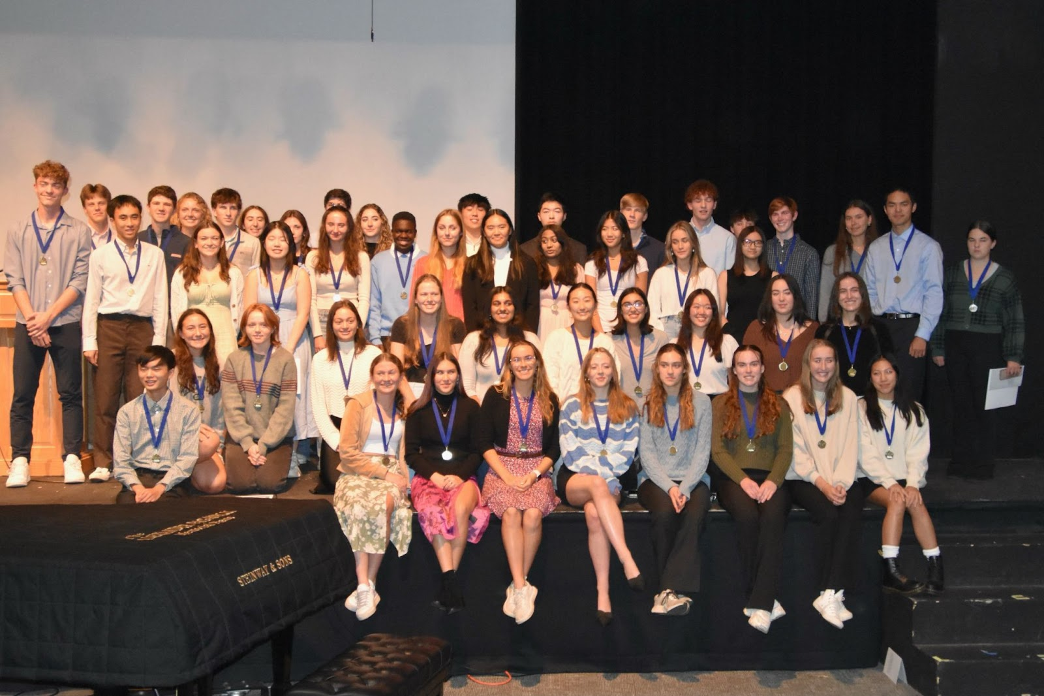
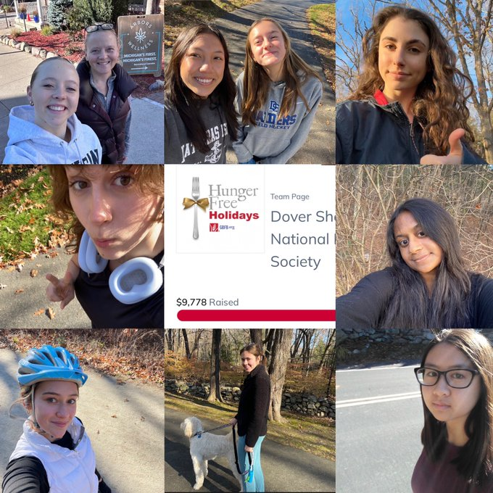
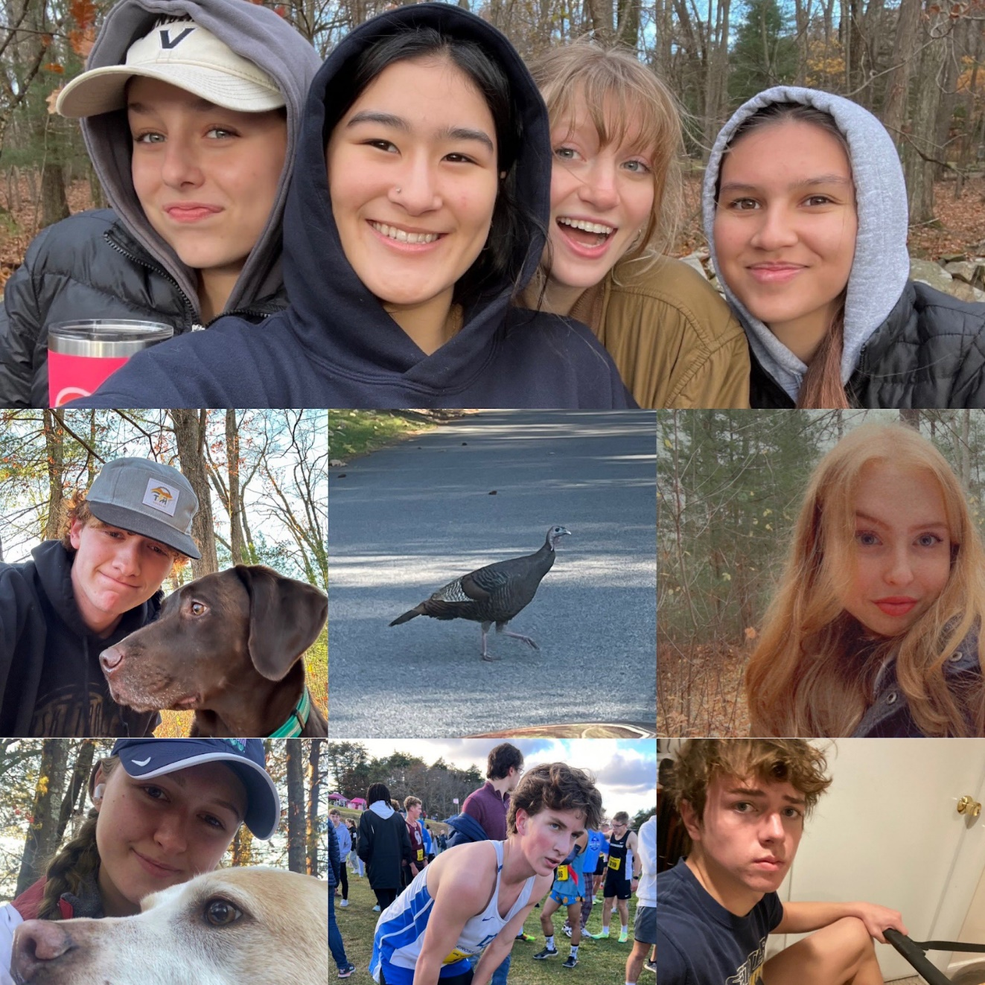

SADD Holiday Campaign

