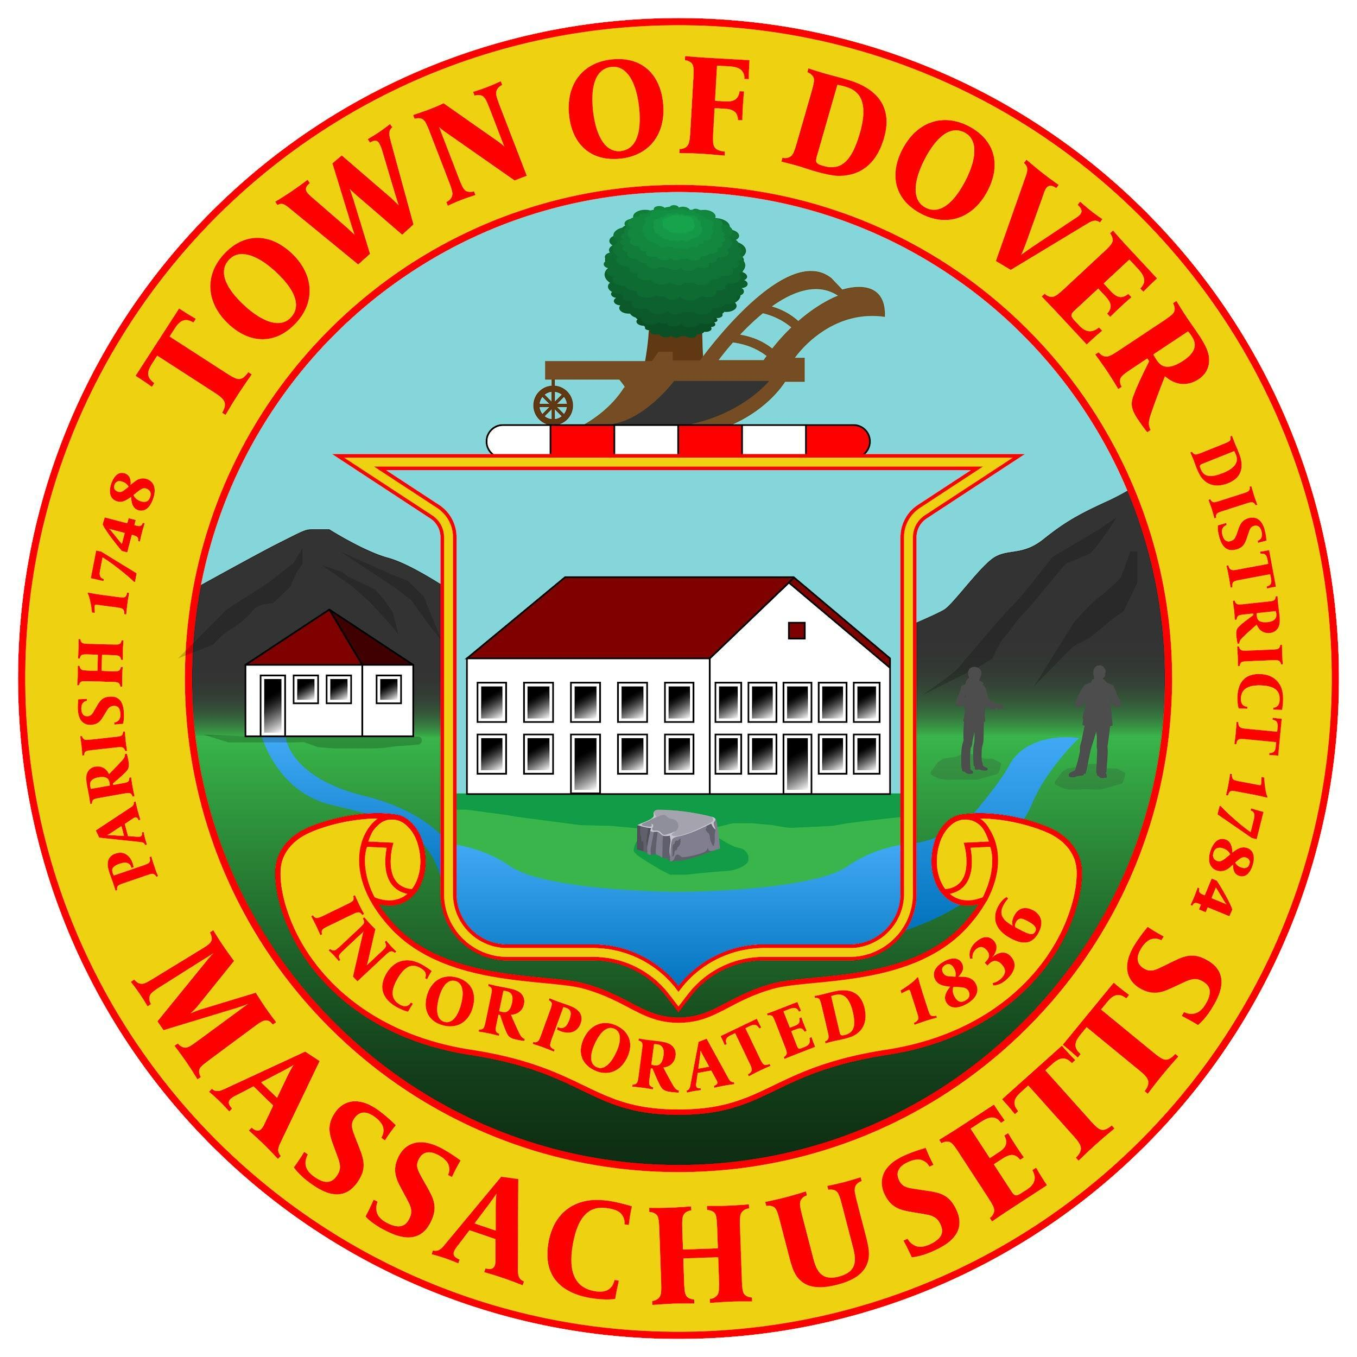
Town of Dover
Board of Health
5 Springdale Avenue
Dover, Massachusetts 02030
NOTICE OF PUBLIC HEARING

Notice is hereby given pursuant to M.G.L. c. 111, § 31 that the Dover Board of Health will hold a public hearing on Monday, November 3, 2025, at 7 PM via Zoom. The Board is proposing changes to:

Chapter 220 Smoking; Sale of Tobacco and Nicotine Delivery Products

The Dover Board of Health proposes to adopt The Nicotine-Free Generation policy, which would become effective January 1, 2026, prohibiting the sale of tobacco or e-cigarette products to individuals born on or after January 1, 2005. The adopted policy language is as follows: "Prohibition of Sales – No person, firm, corporation, establishment, or agency shall sell tobacco or e-cigarette products to anyone born on or after 1/1/2005.”

The purpose of this amendment is to protect the health of Dover residents by reducing youth access to tobacco and nicotine products and preventing addiction in future generations.

Any person wishing to be heard on the matter should appear at the date and time listed above. The link to the meeting will be provided on the Town website. Comments can also be forwarded to BOH@doverma.gov prior to the hearing or you can contact the office directly at 508-785-0032 ext. 232. A copy of the proposed changes to the regulation can also be obtained upon request.

Jason Belmonte, R.S, CHO, CP-FS
Health Director
October 16, 2025

To be advertised in Hometown Weekly no later than October 23, 2025

