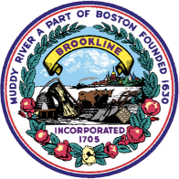
TOBACCO SALES NOTICE
The Sale of Tobacco or E-Cigarette Products to Someone Born On or after 1/1/2000 is Prohibited.
(Brookline Town By-Law Article 8.23 S 5 (d) (h) 2 (i) 2)
Violations can result in $300 fine and Permit Revocation
TOWN OF BROOKLINE - DEPARTMENT OF PUBLIC HEALTH
11 Pierce Street, Brookline, Massachusetts, 20445
Telephone: 617-730-2300
Sigalle Reiss, MPH, RS/REHS
Director of Public Health & Human Services

